Movie Shop Web Application

# Quick Start Guide

Version 1.0

2020/11/11

Document Revision History

| Version Number | Date | Author/Owner | Description of Change |
| --- | --- | --- | --- |
| 1.0 | 2020/11/11 | Romesh Jayawardene | Initial version |
|  |  |  |  |
|  |  |  |  |
|  |  |  |  |
|  |  |  |  |
|  |  |  |  |
|  |  |  |  |
|  |  |  |  |
|  |  |  |  |
|  |  |  |  |
|  |  |  |  |

Table of Contents

1.1 Introduction 4

1.2 Logging in as admin 4

1.3 Setting up 5

1.4 Adding movies to the library 6

1.5 Browsing the titles available in the library 8

1.6 Editing and removing the titles available in the library 10

1.7 Login for customer 10

1.8 Movie search Analysis 11

1.9 Responsive design 12

### Introduction

Movie Shop is an app that can be used for managing a movie library in a DVD rental store.

Functionality is divided into 3 main categories:

1. Adding movies to the library
2. Browsing the titles available in the library
3. Configuring settings

The app also allows potential customers to login and browse the available titles.

Following are the user flows:

### Logging in as admin

In order to login as admin, you need to manually visit the page <hosted URL>/login-admin. This is hidden from the welcome screen, as the latter is accessible to customers.

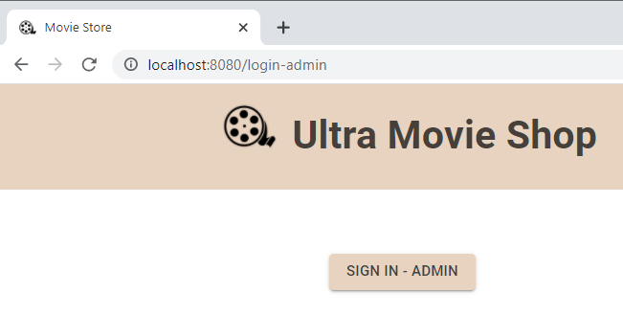

Clicking on Sign in-Admin will take you to the login screen. You may enter the username and password provided by the app vendor:

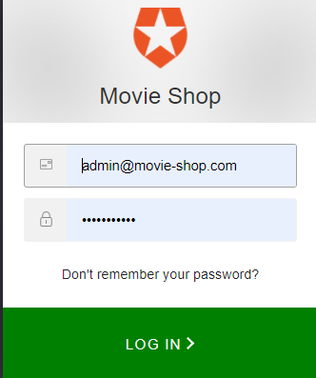

### Setting up

Once logged in, the admin needs to setup some mandatory information in order to use the app functionality under the ‘Settings’ tab.

1. An OMDB API key needs to be obtained. This can be done via <http://www.omdbapi.com/apikey.aspx>. For free or at a price. This key must be inserted into the ‘OMDB API key’ field.
2. Languages of titles that customers will wish to browse must be added as a comma-separated string under ‘Languages’ field.

See the figure below to notice some filled-in fields.

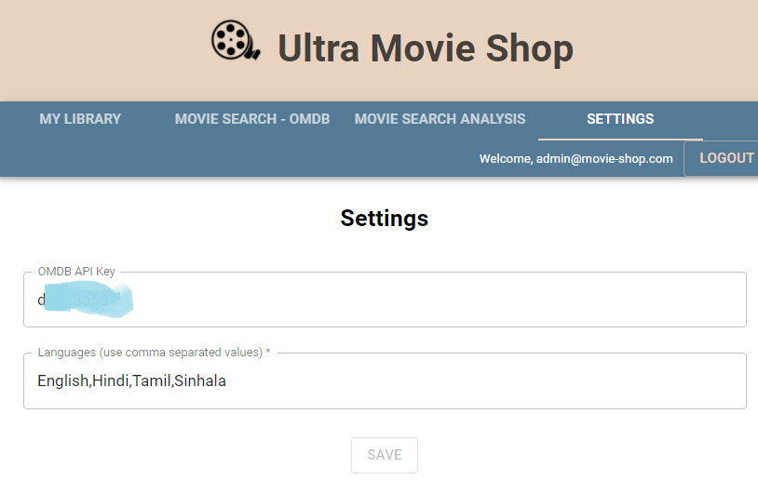

### Adding movies to the library

Instead of having to manually add all movie-related information into the app, the app allows the admin to search the OMDB database for a movie. Once the movie is found, then the admin can add that title to the library. Then all the movie related metadata is automatically added. The ‘Movie Search – OMDB’ tab can be used for this.

E.g.: to add ‘The Matrix’ movie, follow the steps below:

Type ‘the matrix’ in the search box and press ‘Search’ :

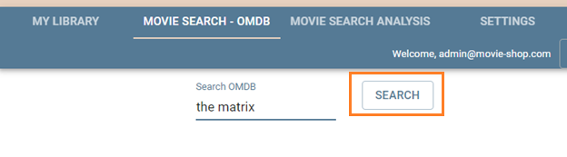

Then all the matching results from OMDB are displayed:

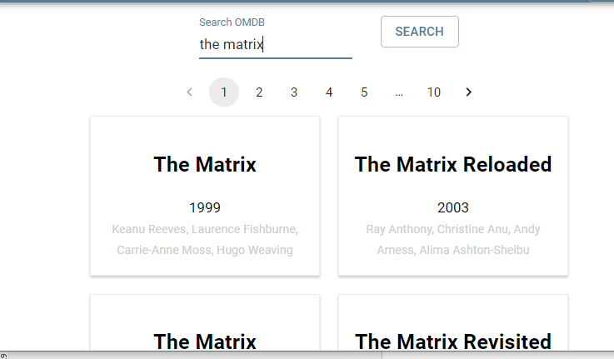

Click on ‘The Matrix’, since it is the movie we wish to add. A sidebar pops up on the right providing some more details of the movie:

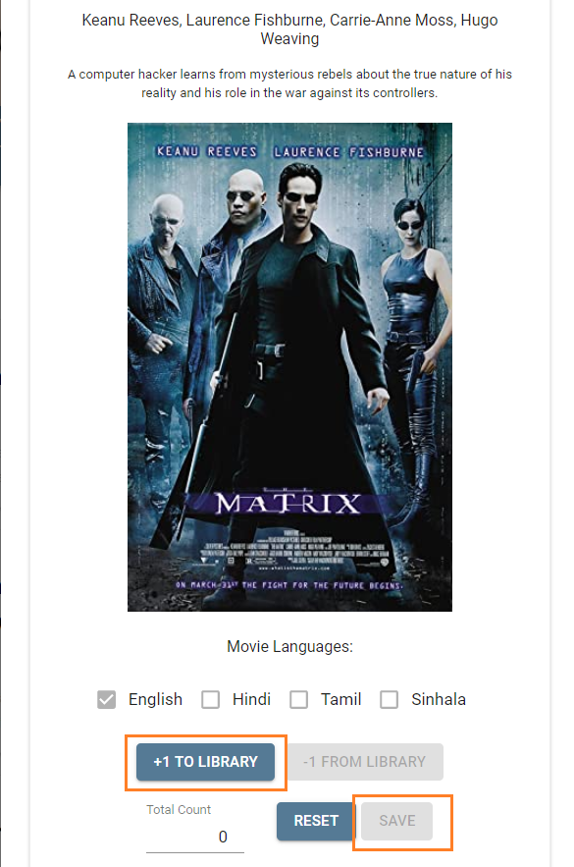

Now click ‘+1 to Library’ and ‘Save’. Then the movie and its related metadata gets added to the library.

### Browsing the titles available in the library

Now we can proceed to the ‘My Library’ tab and view the movie we just added.

Enter ‘the matrix’ in the Title search box, and press ‘Search’.

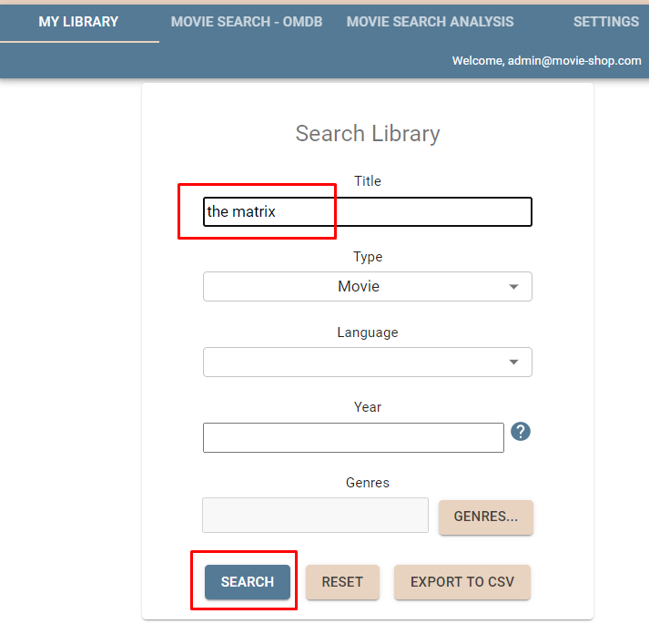

Now you will see the movie displayed in the table below:

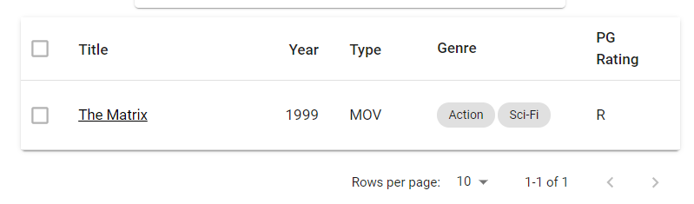

You can now click on the movie title to view more details in the sidebar, just as in Section 1.4.

In order to search for titles, you need to enter either the Title, Type (Movie/TV Series), Language, year or genre(s). A year to search for can be entered in one of the following formats:

            To enter a single year: 2020

            To enter a year to search from: > 2020

            To enter a year to search upto: < 2020

            To enter a range of years: 2010-2020

The titles that we searched can be exported to a CSV file by pressing ‘Export to CSV’.

### Editing and removing the titles available in the library

Existing titles in the library can be edited in the following 2 ways in the movie details sidebar:

* Languages can be added or removed
* Quantity of the title can be increased or decreased.

Multiple titles can be removed at the same time, by selecting the rows and clicking “delete” icon in the table actions:

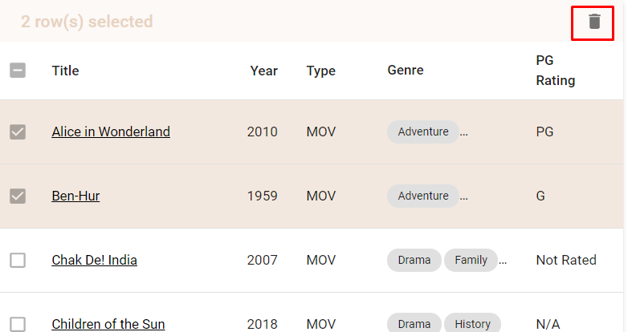

### Login for customer

When visiting the hosted URL for the app, the potential customers can login and browse the available titles. Here is the welcome screen viewed by the customers:

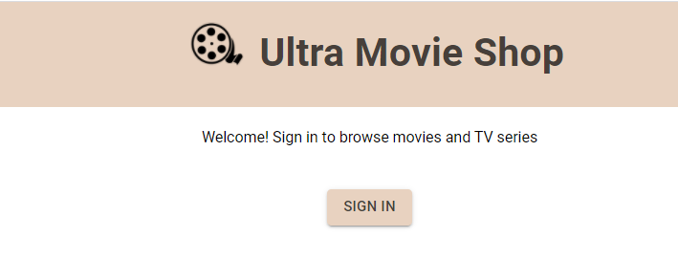

Currently, customers need to sign in with their Google account:

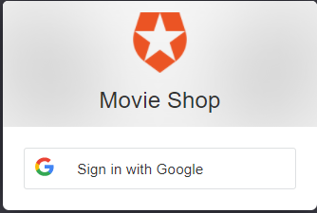

Signing in is mandatory to avoid unwanted resource usage by hackers.

Once logged in, only the ‘My Library’ tab contents are visible to the customer, similar to section 1.5. However, they are barred from editing the quantity or languages of the titles in the movie details sidebar.

### Movie search Analysis

This is an analytic feature of the app, accessible to the Admin. There are 2 types of graphs visible in this page:

1. Library Movie Analysis

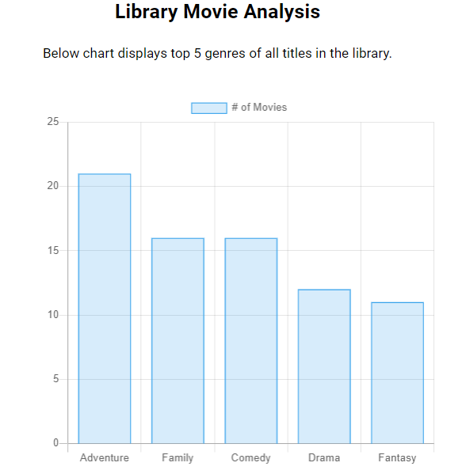

2. Search Movie Analysis

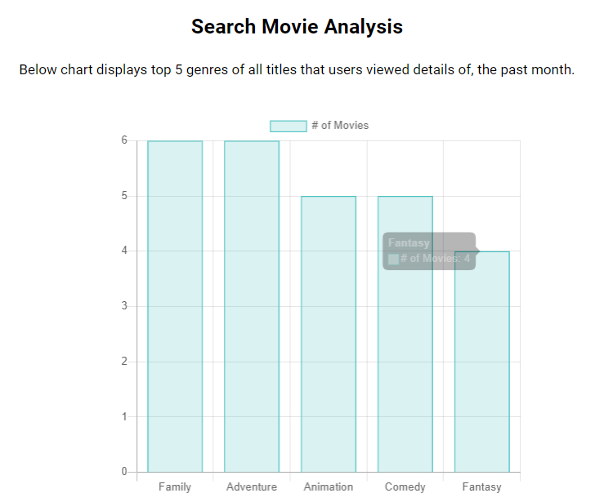

These 2 graphs are meant to help the rental shop owner view which genres of movies the customers are searching, and decide how to expand the collection of titles accordingly to match customer demand.

### Responsive design

The admin-accessible screens are meant to be used via a large screen, but the customer portal is mobile friendly. Here is the mobile view:

